1. The Ohio Environmental Protection Agency used the Index of Biotic Integrity (IBI) to measure the biological condition, or "health," of an aquatic region. The IBI is the sum of metrics that measure the presence, abundance, and health of fish in the region. (Higher values of the IBI correspond to healthier fish populations.) Researcher collected IBI measurements for sites located in different Ohio river basins. *(Journal of Agricultural. Biological, and Environmental Sciences, June 2005.)* Summary data for two river basins, Muskingum and Hocking. are given in the accompanying table.

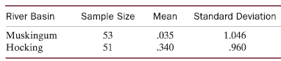

Conduct a test of hypothesis (at α = .10) to compare the mean IBI values of the two river basins.

2.

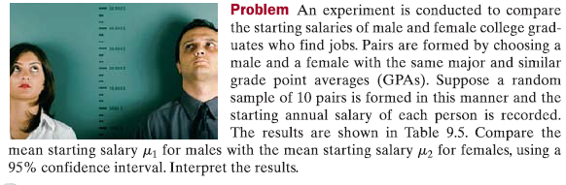



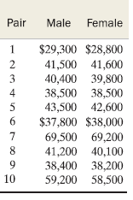

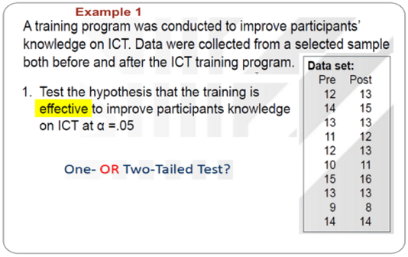

4.

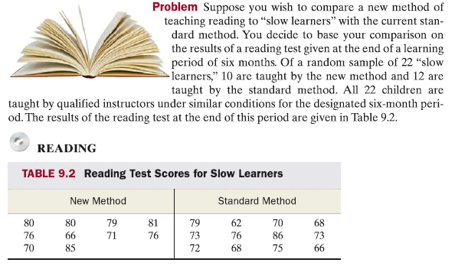

Use the data in the table to estimate the true mean difference between the test scores for the new method and the standard method.